HOPS Bullying Policy
Bullying involves persistent abuse which intimidates, threatens or has a harmful or distressing impact on another child or children. This can be emotional, physical, racist, verbal, sexual or cyber (text messages).
Bullying of any form is unacceptable to the HOPS Committee and Staff.

In any instance of bullying the Staff or Management Committee will:

- Intervene to stop the incident.
- Explain to the child why their behaviour is inappropriate.
- Reassure the child that has been bullied.
- Encourage the child who has carried out the bullying to apologise.
- Discuss the incident with the parents/carers of the bullied child and explain what action has been taken.
- Discuss the incident with the parents/carers of the bullying child and, where appropriate, agree a plan to improve behaviour.

In the event that a satisfactory conclusion cannot be reached with the bullying child or their parents/carers then more serious action involving suspension and exclusion will be implemented, at the discretion of the Committee.

Signed: Emma Taylor
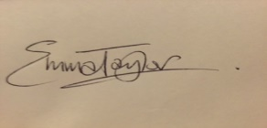

Title: Chair

Date: July 2016

