HOPS Code of Conduct

All committee members, play helpers, room leaders (hereby referred to as staff) and external activity providers are expected to adhere to this Code of Conduct.

Appearance: Clothes suitable for HOPS activities should be worn. Committee members should wear the HOPS red T-shirts at all times. All staff should be presentable.

Smoking, alcohol and drugs: No staff member or external provider should be under the influence of drugs or alcohol at any time, nor is smoking permitted during HOPS on the premises at any time. Violation of this rule will result in immediate dismissal.

Respect: Staff members and external providers are expected to be respectful towards other staff and the children attending HOPS at all times. This includes respectful language and body language. Swearing, aggression and aggressive body language will not be tolerated.

Timekeeping: Staff and external providers are expected to be on time for HOPS as detailed in their contracts or information pack, as applicable.

Relationships: Intimate relationships should not be visible during HOPS. If your partner also works at HOPS, your interactions should be the same as with any other staff member. Failure to adhere to this will result in disciplinary action.

Please also refer to HOPS policies on Bullying, Discipline, and Behaviour Management, as well as generally all other HOPS policies as available in the Induction Pack.

Signed: Emma Taylor
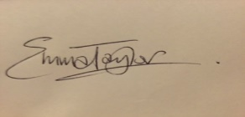

Title: Chair

Date: July 2016

