HOPS Discipline Policy

No individual staff member will decide what measures should be taken to discipline a child whilst at HOPS.

All incidents of unacceptable behaviour must be reported to a member of the committee and/or the Play Leader who will decide what action is to be taken.

The member management committee and/or Play Leader to whom the incident is reported must record details in the day book which is held at the committee desk. Both committee member and staff member reporting the incident should sign the record in the day book.

The management committee will agree on the action, if any, to be taken.

The parent/carer should be advised verbally by a member of the management committee of the incident and action/s taken. Any disciplinary action will be put in writing to the parent/carer for when the child is
collected.

Should the management committee decide that it is appropriate for a child to be removed from HOPS, the parent/carer should be advised of the decision in writing and the letter signed by the committee member and/or Play Leader involved with the decision. This letter of explanation must be handed to the parent/carer when the child is collected, together with a verbal explanation of why the suspension has been imposed.

Please also refer to HOPS Behaviour Management Policy and HOPS Bullying Policy as supporting materials

Signed: Emma Taylor
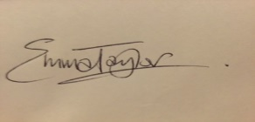

Title: Chair

Date: July 2016

