HOPS COMPLAINTS POLICY
All Complaints must be dealt with in a precise and formal manner; please read the following policy points:
• All complaints are to be directed to the COMMITTEE and PLAY LEADER. Complaints ARE NOT to be dealt with by playhelpers.
• All complaints MUST be entered into the HOPS DAY BOOK that is located on the COMMITTEE DESK. Complaints must contain as much detail as possible and are to be signed and dated by the complainant and committee member/play leader.
• If the complainant is happy for the complaint to be dealt with verbally, details must be entered into the DAY BOOK and signed and dated by both complainant and committee member/play leader.
• If the complaint requires a WRITTEN RESPONSE this must be provided by the Play Leader or Committee Chair within 28 DAYS of the date of the complaint ensuring that all raised points are covered; if further investigation is needed, the complainant MUST BE ADVISED IN WRITING within the 28 day period.
• All correspondence MUST BE FILED in the COMPLAINTS FILE found at the Committee Desk.

Signed: Emma Taylor
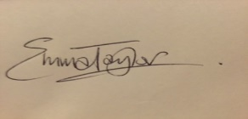

Title: Chair

Date: July 2016

